Excellent question 👏 — This is very common HLD confusion and interviewers purposely ask this to check system understanding.
https://www.youtube.com/watch?v=BWB-S0awDnA

You are basically asking:
👉 What exactly Load Balancer does beyond distributing load
👉 Where Load Balancer sits vs API Gateway
👉 Which comes first
👉 What interview expects you to know
Let’s make this HLD + Interview Ready.

🎯 1️⃣ What is Load Balancer (Beyond Just Distributing Load)
✅ Basic Definition
Load balancer distributes incoming traffic across multiple servers to improve availability and scalability.
📌 Interview Line:
Load balancer ensures high availability, fault tolerance, and horizontal scalability by distributing traffic across multiple service instances.
It handles the incoming request and route request efficiently to the correct server.

✅ What Else Load Balancer Does (Interviewers Expect This)
Most candidates only say “distributes load” ❌
You must mention these:

🔹 High Availability
If one server fails → traffic automatically routed to healthy server.
until the system recovers

🔹 Fault Tolerance
Detects unhealthy instances using:
- Health checks
- Heartbeat monitoring

🔹 Scalability
Supports:
- Horizontal scaling
- Auto-scaling

🔹 Performance Improvement
Reduces latency by:
- Routing to nearest server
- Connection pooling
- Caching (sometimes)

🔹 SSL Termination
Load balancer can handle:
- HTTPS decryption
- Reduces backend CPU load

🔹 Traffic Shaping
Supports:
- Canary deployment
- Blue-green deployment
- Weighted routing
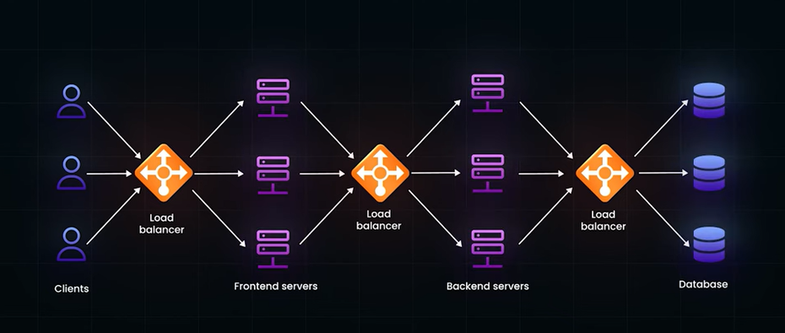
LB can seats between any layer system ,to optimise the request routing

🎯 2️⃣ Types of Load Balancers (Very Important)

Layer 4 Load Balancer (Transport Layer)
Works using:
- TCP
- IP
- Port
Fast but less intelligent.
Example:
👉 AWS NLB

Layer 7 Load Balancer (Application Layer)
Works using:
- HTTP headers
- URL path
- Cookies
More intelligent routing.
Example:
👉 Nginx
👉 AWS ALB

📌 Interview Tip:
API Gateway usually behaves like Layer 7 load balancer + extra features.

🎯 3️⃣ Load Balancer vs API Gateway (Important Comparison)
Feature | Load Balancer | API Gateway
Purpose | Distribute traffic | Manage APIs
Routing | Based on network/app rules | Based on API logic
Authentication | Usually No | Yes
Rate limiting | Rare | Yes
Aggregation | No | Yes
Protocol handling | Basic | Advanced

🎯 4️⃣ Which Comes First? (VERY COMMON INTERVIEW QUESTION)
⭐ Real Production Architecture
Client
↓
Load Balancer
↓
API Gateway (multiple instances)
↓
Microservices

✅ Why Load Balancer Comes Before Gateway
Because:
👉 API Gateway itself must scale
👉 Gateway instances need distribution
👉 Avoid gateway becoming bottleneck
👉 Provide high availability

📌 Interview Answer:
Load balancer is placed in front of API Gateway to distribute traffic across multiple gateway instances and ensure high availability.

🎯 5️⃣ Where Load Balancer Is Also Used (Many Candidates Miss This)
Load balancer is NOT only used at front.
It is used:

🔹 Between Gateway and Services
Gateway → Load Balancer → Service instances

🔹 Between Microservices
Service-to-service calls can use load balancing.

🔹 Inside Kubernetes
- Service object
- Ingress controller

🎯 6️⃣ Load Balancing Algorithms (Must Know)

Round Robin
Requests distributed sequentially.

Least Connections
Routes to server with least active connections.

Weighted Routing
More traffic to stronger servers.

Hash-based Routing
Used for session stickiness.

🎯 7️⃣ Real HLD Example
Imagine e-commerce system:
Millions of users → Load Balancer
↓
Multiple API Gateways
↓
Order / Payment / User Services

🎯 8️⃣ When Load Balancer Alone Is Enough
Small system:
Client → Load Balancer → Backend Servers

🎯 9️⃣ When You Need Both
Large microservices architecture:
- Multiple services
- Security requirement
- Multiple clients
- Aggregation needed

🎯 🔥 Interview Trick Question
👉 “Can API Gateway replace Load Balancer?”
Correct answer:
API Gateway provides some load balancing capabilities, but in large systems we still place a dedicated load balancer in front for scalability and fault tolerance.

🎯 1️⃣0️⃣ Trade-Offs
Load Balancer Problems:
- Extra infrastructure
- Cost
- Configuration complexity

⭐ Perfect Interview Summary
Load balancer distributes traffic across multiple service instances to ensure scalability, availability, and fault tolerance. In microservices architecture, load balancers are typically placed before API Gateway to distribute traffic across gateway instances, and also used internally between services.

🧠 Easy Memory Structure
👉 Load Balancer = Availability + Distribution
👉 API Gateway = Security + API Management

🚀 Real FAANG-Level Follow-up Questions (Expect These)
1️⃣ Difference between Layer 4 and Layer 7 load balancing
2️⃣ How does load balancer detect unhealthy instances
3️⃣ How do you handle session stickiness
4️⃣ Global load balancing vs regional
5️⃣ Load balancing in Kubernetes
6️⃣ How CDN relates to load balancing

If you want to seriously master HLD, next best topic is:
👉 Service Discovery (fits perfectly with load balancing)
Should we go next into Service Discovery or do you want mock interview grilling on Load Balancer + Gateway?

